FUNDAMENTALS OF DATA SCIENCE

LAB PROGRAMS

DSA 0412-Fundamentals Of Data Science for Data Analytics

M S GOWRISH SHANKAR REDDY
192424270

07/01/2026

1. Scenario: You are working on a project that involves analyzing student performance data for a class of 32 students. The data is stored in a NumPy array named student_scores, where each row represents a student and each column represents a different subject. The subjects are arranged in the following order: Math, Science, English, and History. Your task is to calculate the average score for each subject and identify the subject with the highest average score.
Question: How would you use NumPy arrays to calculate the average score for each subject and determine the subject with the highest average score? Assume 4x4 matrix that stores marks of each student in given order.
Code:
import numpy as np
student_scores = np.loadtxt("Students_data.csv",delimiter=",",skiprows=1,usecols=(1, 2, 3, 4))
subjects = ["Math", "Science", "English", "History"]

average_scores = np.mean(student_scores, axis=0)

highest_subject = subjects[np.argmax(average_scores)]

print("Average scores:", np.round(average_scores,2))
print("Subject with highest average score:", highest_subject)
output:
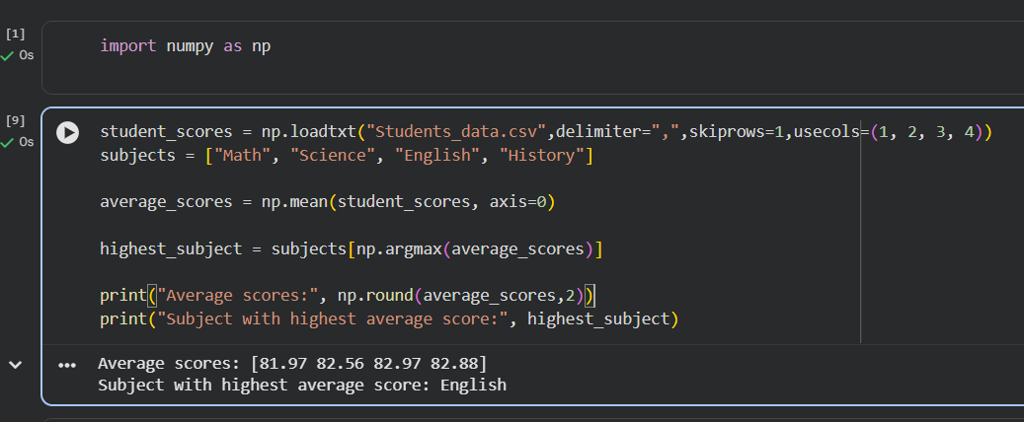

2. Scenario: You are a data analyst working for a company that sells products online. You have been tasked with analyzing the sales data for the past month. The data is stored in a NumPy array.
Question: How would you find the average price of all the products sold in the past month?
Assume 3x3 matrix with each row representing the sales for a different product
Code:
import pandas as pd

df = pd.read_csv("Sales_data.csv")

average_price = df[df["Month_sales"] == "November 2023"]["Price"].mean()

print("Average price in November 2023 (Past Month):", round(average_price, 2))

output:
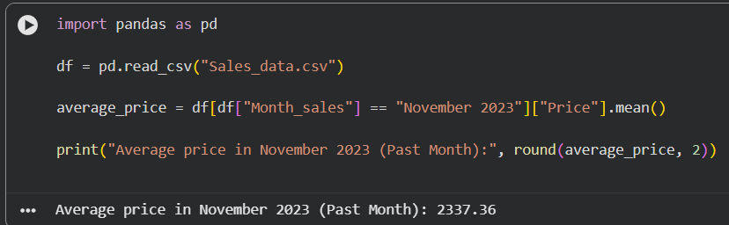

3. Scenario: You are working on a project that involves analyzing a dataset containing information about houses in a neighborhood. The dataset is stored in a CSV file, and you have imported it into a NumPy array named house_data. Each row of the array represents a house, and the columns contain various features such as the number of bedrooms, square footage, and sale price.
Question: Using NumPy arrays and operations, how would you find the average sale price of houses with more than four bedrooms in the neighborhood?
Code:
import numpy as np
house_data = np.loadtxt(
"house_data.csv",
delimiter=",",
skiprows=1
)

filtered_houses = house_data[house_data[:, 0] > 4]

average_sale_price = np.mean(filtered_houses[:, 2])

print("Average sale price of houses with more than 4 bedrooms:",
round(average_sale_price, 2))
output:
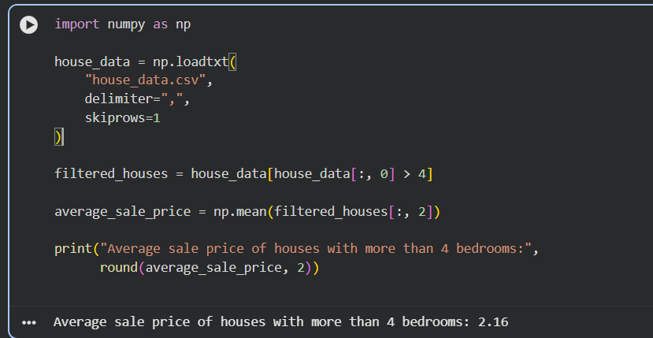

4. Scenario: You are working on a project that involves analyzing the sales performance of a company over the past four quarters. The quarterly sales data is stored in a NumPy array named sales_data, where each element represents the sales amount for a specific quarter. Your task is to calculate the total sales for the year and determine the percentage increase in sales from the first
quarter to the fourth quarter.
Question: Using NumPy arrays and arithmetic operations calculate the total sales for the year and determine the percentage increase in sales from the first quarter to the fourth quarter?
import pandas as pd
import numpy as np
df = pd.read_csv("Sales_data.csv")
q1_sales = df[df["Month_sales"].str.contains("January|February|March")]["Total"].sum()
q4_sales = df[df["Month_sales"].str.contains("October|November|December")]["Total"].sum()
sales_data = np.array([q1_sales, q4_sales])
total_sales = np.sum(df["Total"].to_numpy())
percentage_increase = ((sales_data[1] - sales_data[0]) / sales_data[0]) * 100
print("Total sales for the year:", round(total_sales, 2))
print("Percentage increase from Q1 to Q4:", round(percentage_increase, 2), "%")

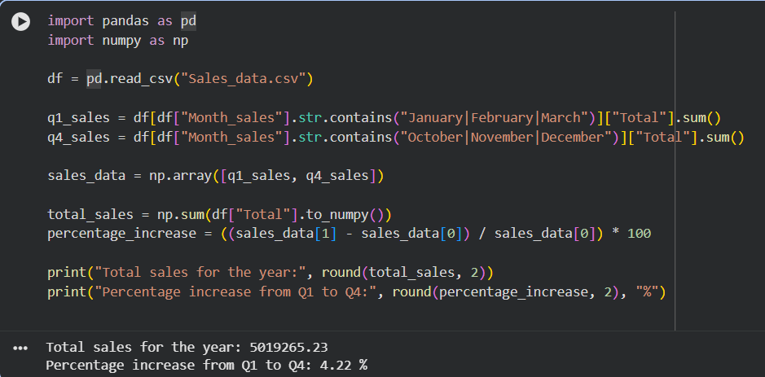

5. Scenario: You are a data analyst working for a car manufacturing company. As part of your analysis, you have a dataset containing information about the fuel efficiency of different car models. The dataset is stored in a NumPy array named fuel_efficiency, where each element represents the fuel efficiency (in miles per gallon) of a specific car model. Your task is to calculate the average fuel efficiency and determine the percentage improvement in fuel efficiency between two car models.
Question: How would you use NumPy arrays and arithmetic operations to calculate the average fuel efficiency and determine the percentage improvement in fuel efficiency between two car models?
import numpy as np
fuel_efficiency = np.loadtxt(
"car.csv",
delimiter=",",
skiprows=1,
usecols=(4,)
)
average_efficiency = np.mean(fuel_efficiency)
percentage_improvement = ((fuel_efficiency[1] - fuel_efficiency[0]) / fuel_efficiency[0]) * 100
print("Average fuel efficiency:", round(average_efficiency, 2))
print("Percentage improvement between two car models:", round(percentage_improvement, 2), "%")

